Kubernetes

Why Kubernetes as orchestration tool

Springboot -container ---deploy ---

Microservice ----services (10) ---10 container ---

Payment ---1 person ---workload was load -50

1 person ------container 1

10 person ------calculator app

------calculator app crashed

Imagine a calculator app which I containererized and it is using by a user

Inside my server machine….suddenly few more peoples joined and started to use this app. So my container cant tolerate overload so I create one more extra container

This is what we called as scaling up.

Application is slow ---so when I check one container got crashed so I created a new

One . now those extra users got removed and one of my container was idle so I removed my extra container this is we called as scale down.

If more users are coming and in my machine I have created 4 containers and cant create no more in the same machine, so I created one more machine and add new container s,so in my one achine high load and in other machine less load

Machine –I can occupy 4 container ----10 persons

Few peoples -I need to create one more container ---new machine ---I have to place this new container

2 machines ----1(4containers-high ) 2 (one container) –low load

So

I need to manually distribute the load . so imagine in an application I have front end backend ,DB so imagine how many containers I have and how I need to mange all manually …so 24hours manual work is need to monitor .

Autoscaling…Kubernetes ----is doing all…music orchestra

All containers are managing by Kubernetes.

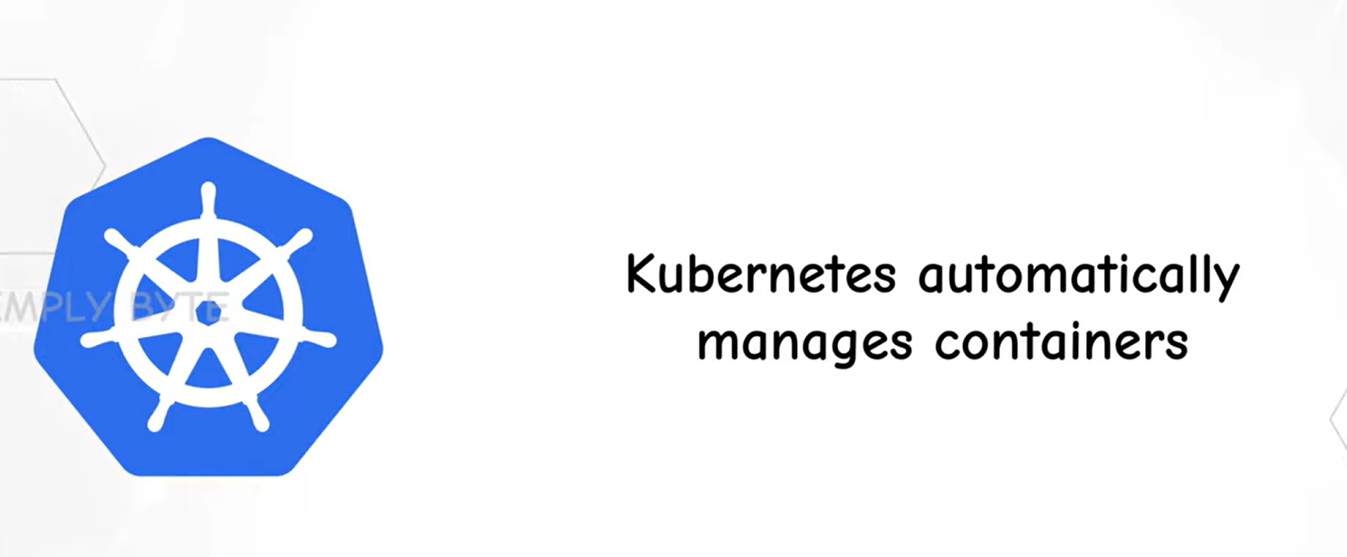

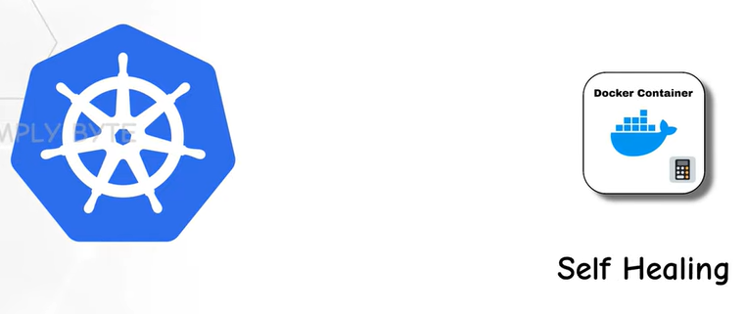

If container got crashed it will create new container ,that is self healing

**Kubernetes Architecture**

Two nodes it have mainly

1.Master Node

2.Worker node

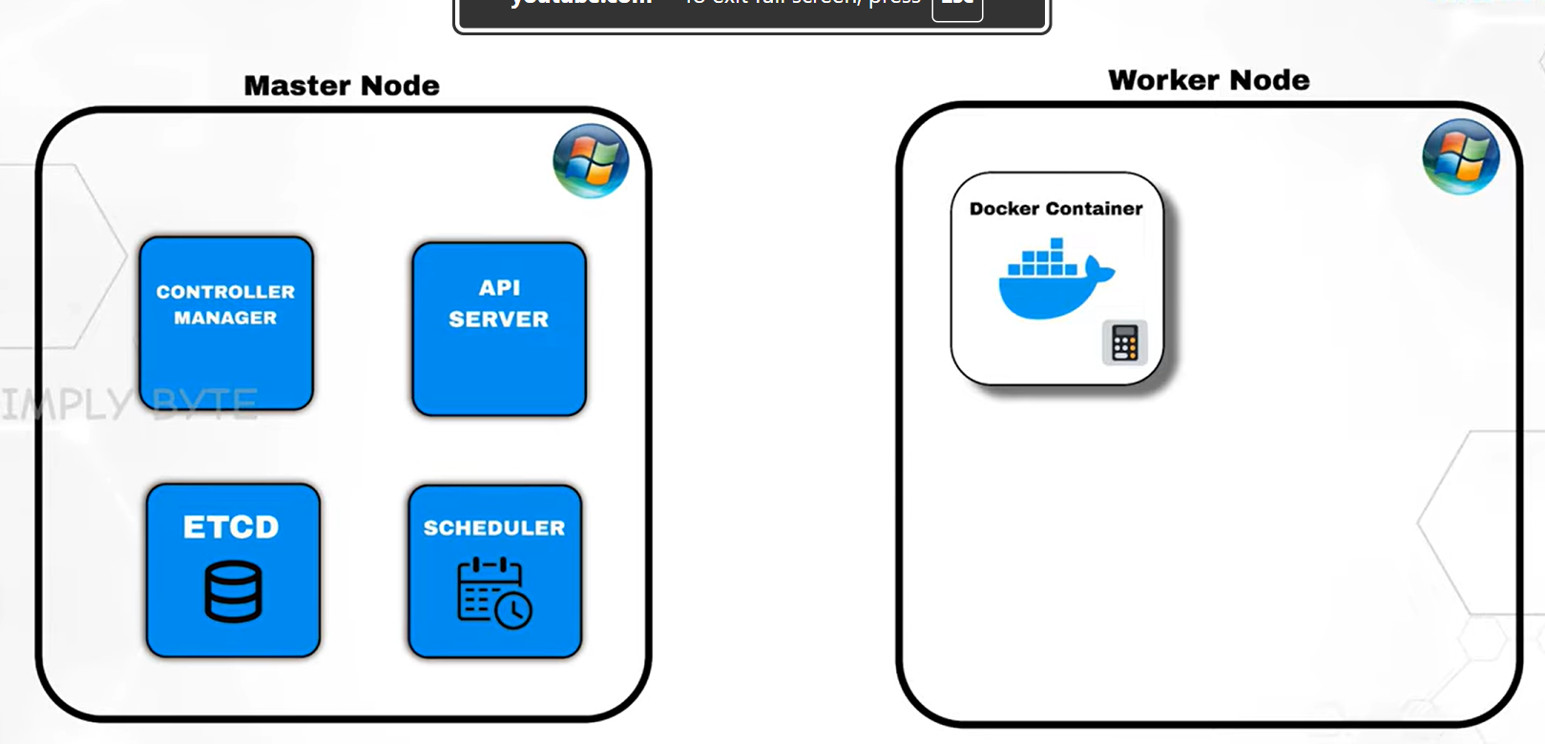

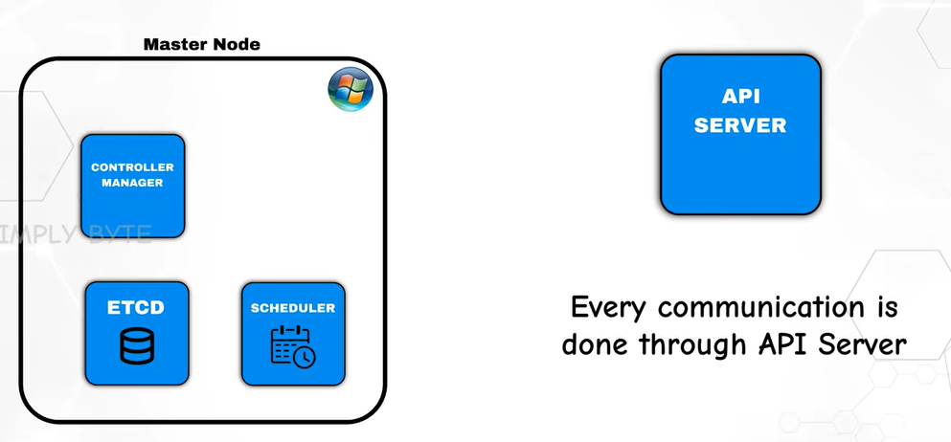

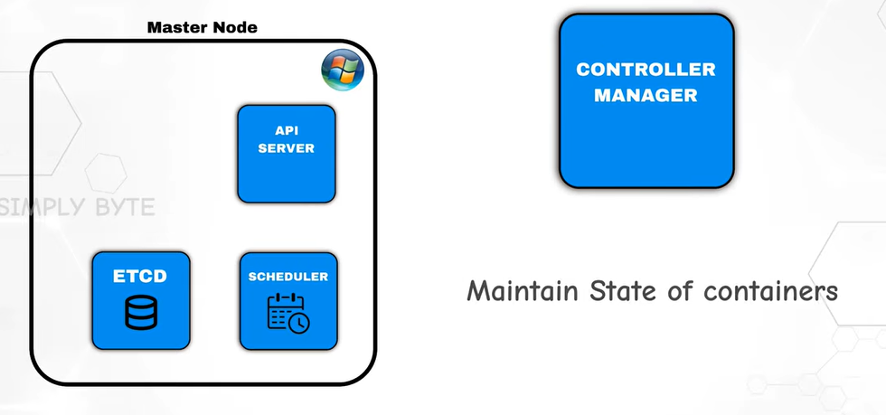

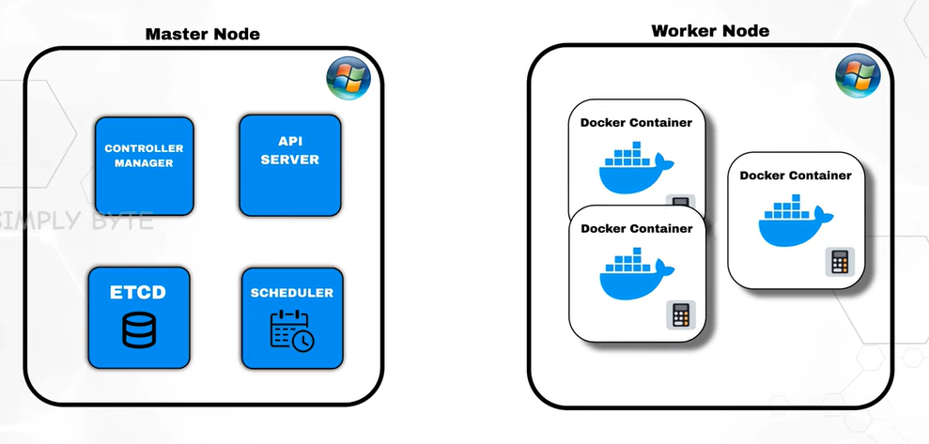

If any of the container got crashed or if we created any extra container ,so the information will ask to controller manager how many containers are there or what is the state of the container.

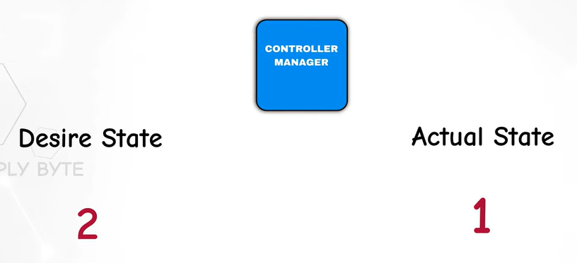

Desire ---how many containers we need to be there if it is 2…actual 1 container will be there so 2-1 =1 ,so he controller manager will tell API manager to create one more container.

How the controller manager knows the desire state is 2?

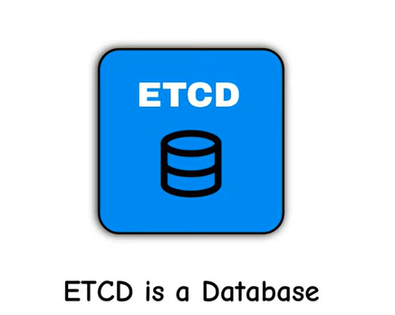

All the datas are stored in this ETCD

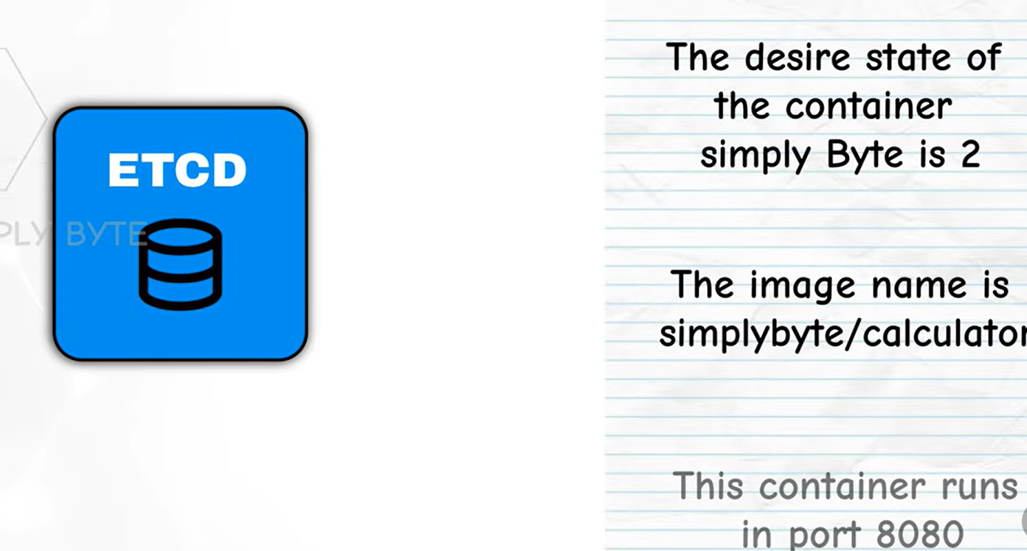

Now if we need to create a new container then in which node the container need to create will be decide by the scheduler

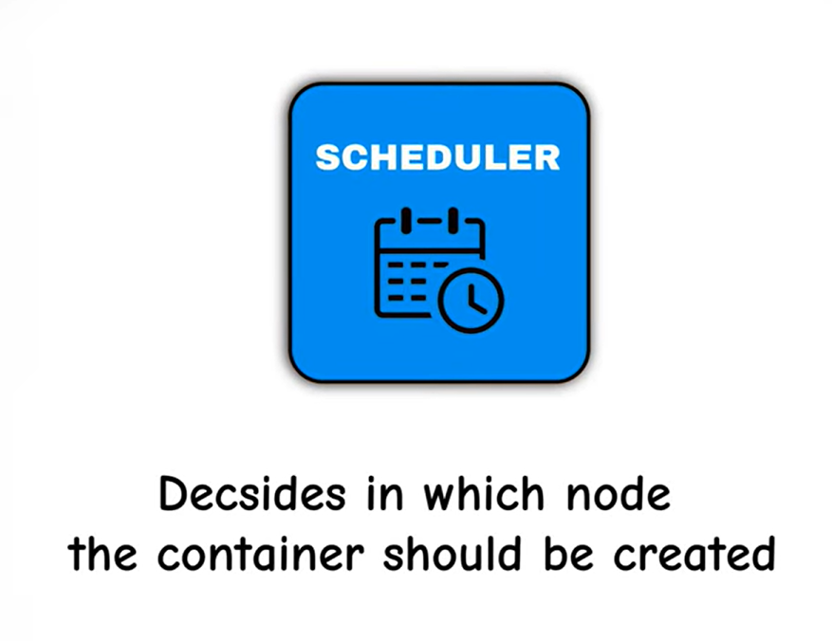

Now through this scheduler , we can understand in which node we need to create the container ,now who is going to create the container?

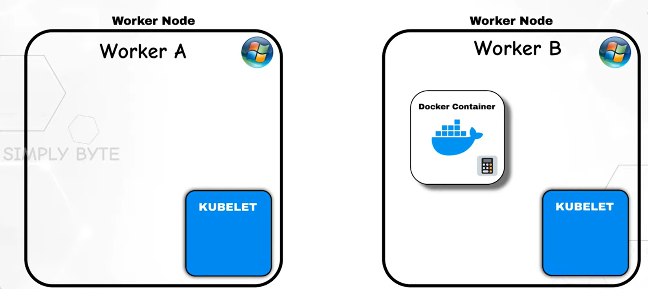

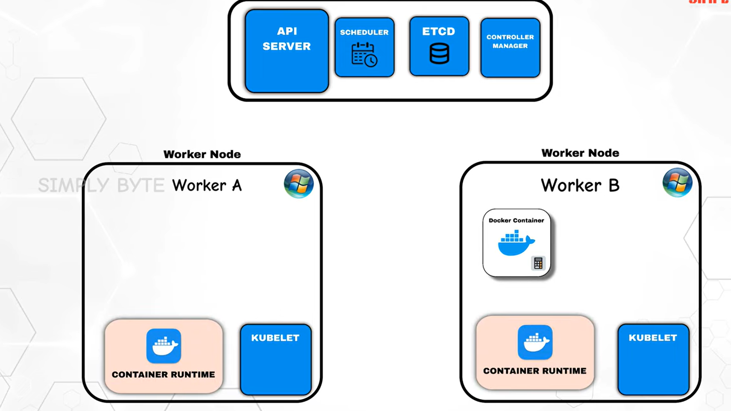

API will tell the kubelet to create the container but he is not going to do this ,this work will given to container runtime because only this can pull the image ,create the container and run it .

Kubelet act as a spy if there any container is crashing inform this to API Server .

What is cluster>Node how to set up in our system

Worker node and Master node . what is node its nothing a server or a machine

Pod will be created in worker node and there are some components who are responsible for monitoring these pod in worker node. Those components are in master node

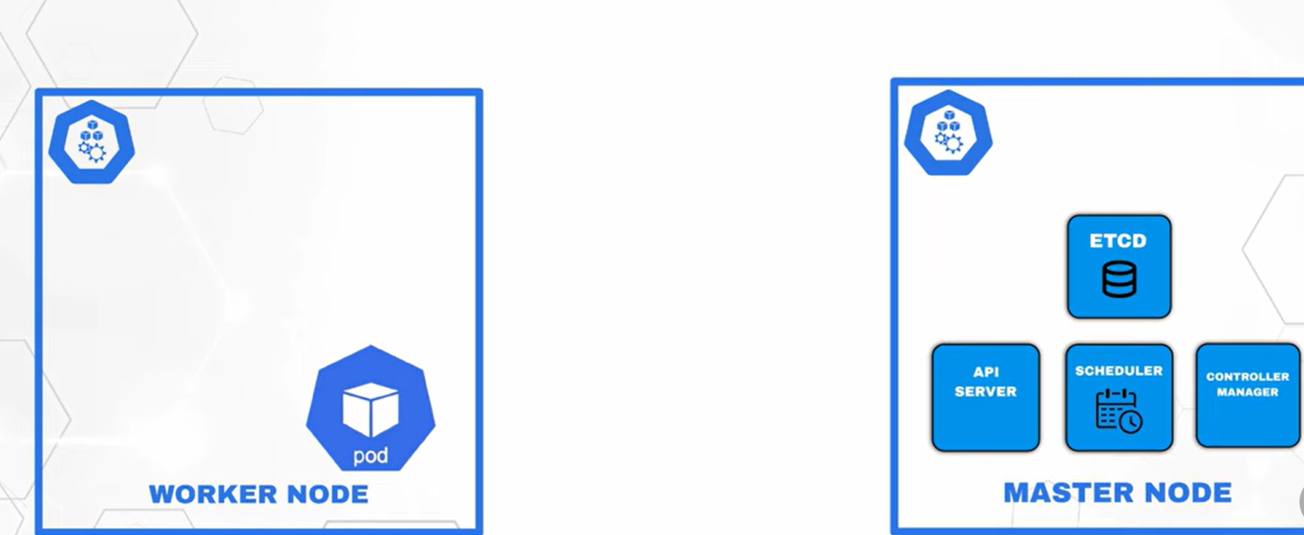

Suppose if more than 5 worker noder are created then one master node cant manange this so it create one more master node

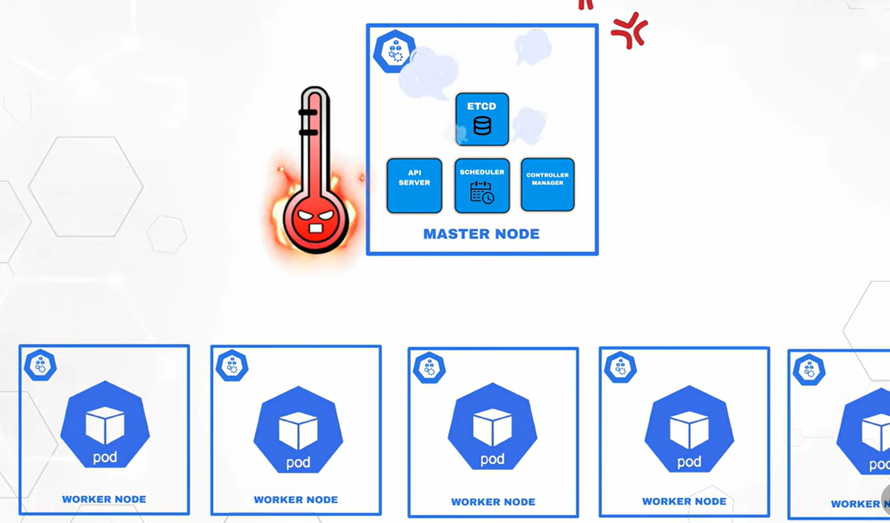

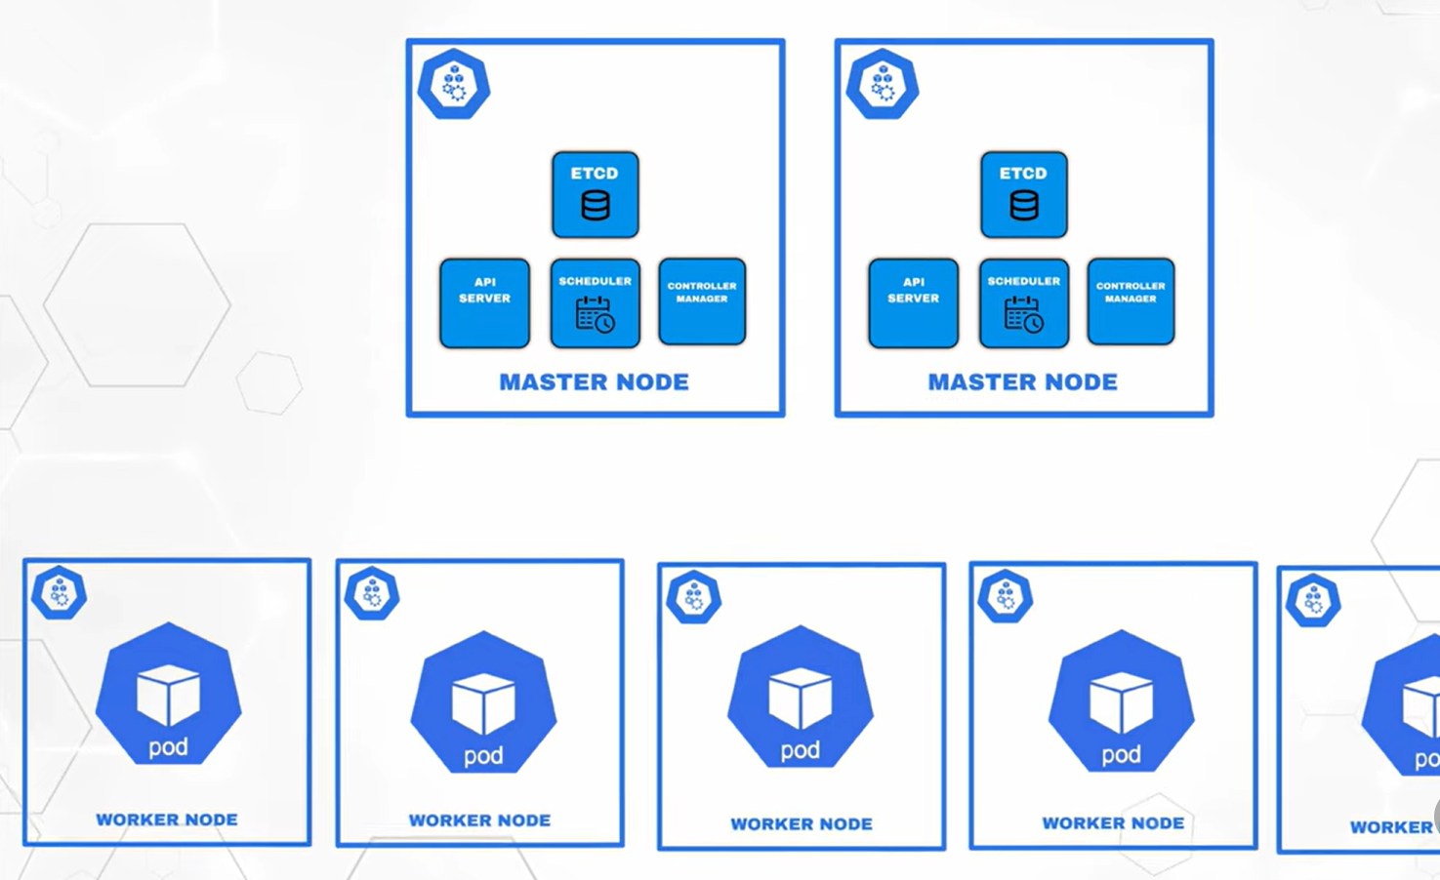

So we are calling this **master node as Control plane**

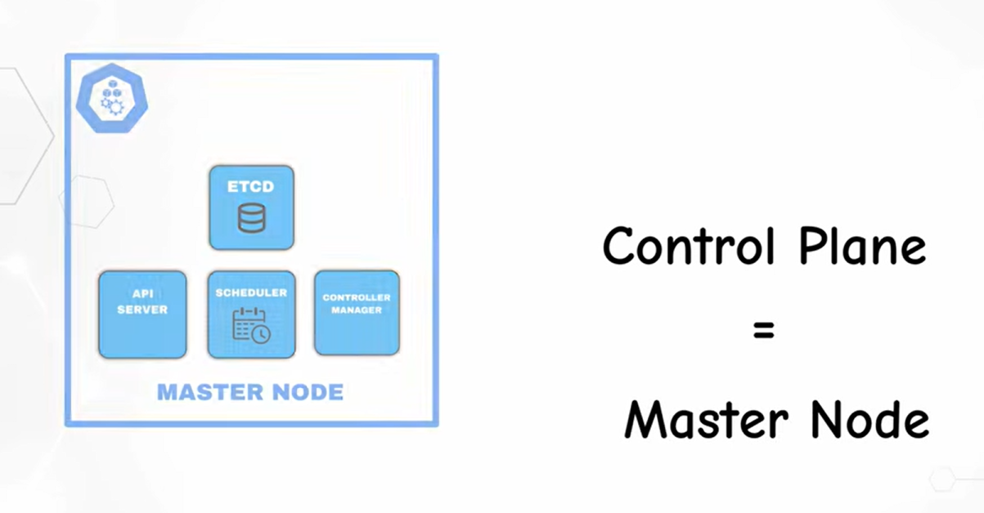

Cluster is nothing but it’s a group of worker node and the master node

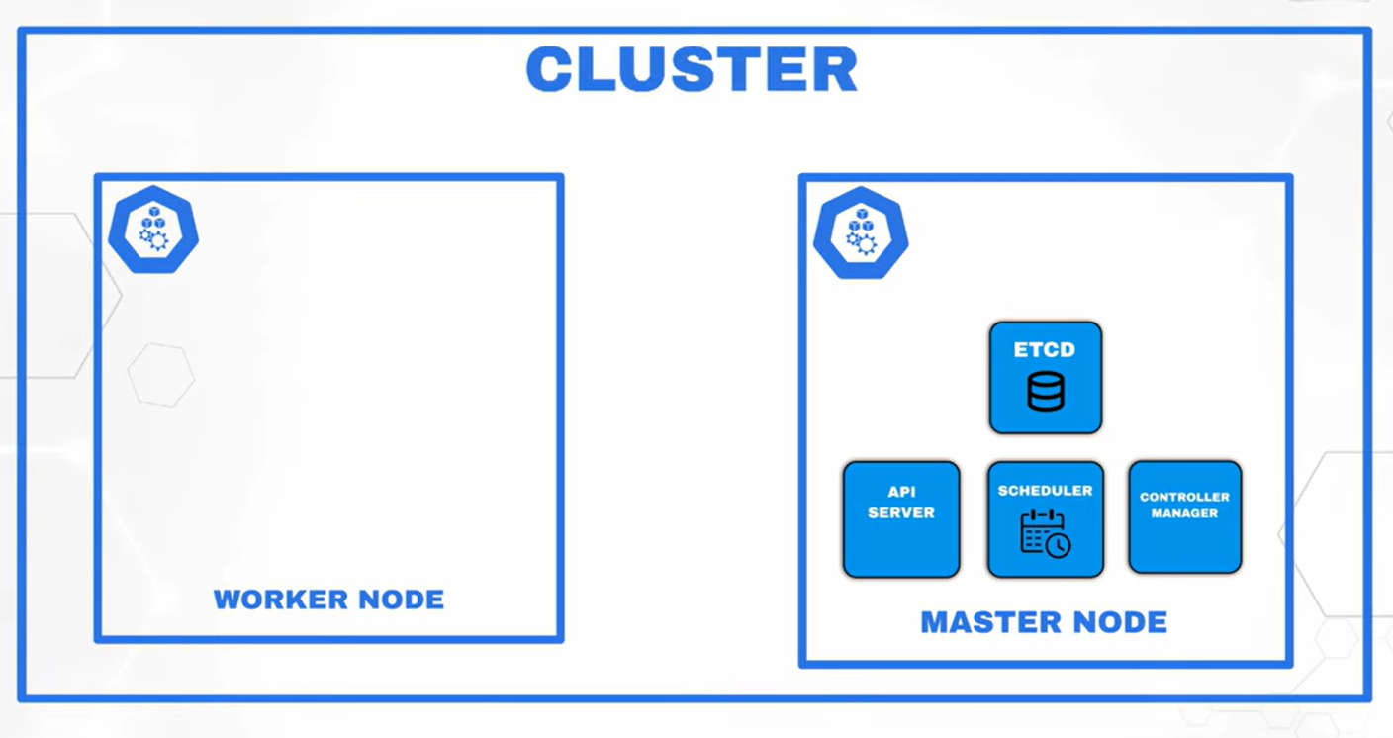

When we are creating a cluster we need to set up two nodes one master node and worker node, node is nothing but a server . so we have to create the server and we have to tell this is cluster node this is master node this is what we used to say as cluster setup.It is a big process so cloud services like amazon providing as Amazon EKS

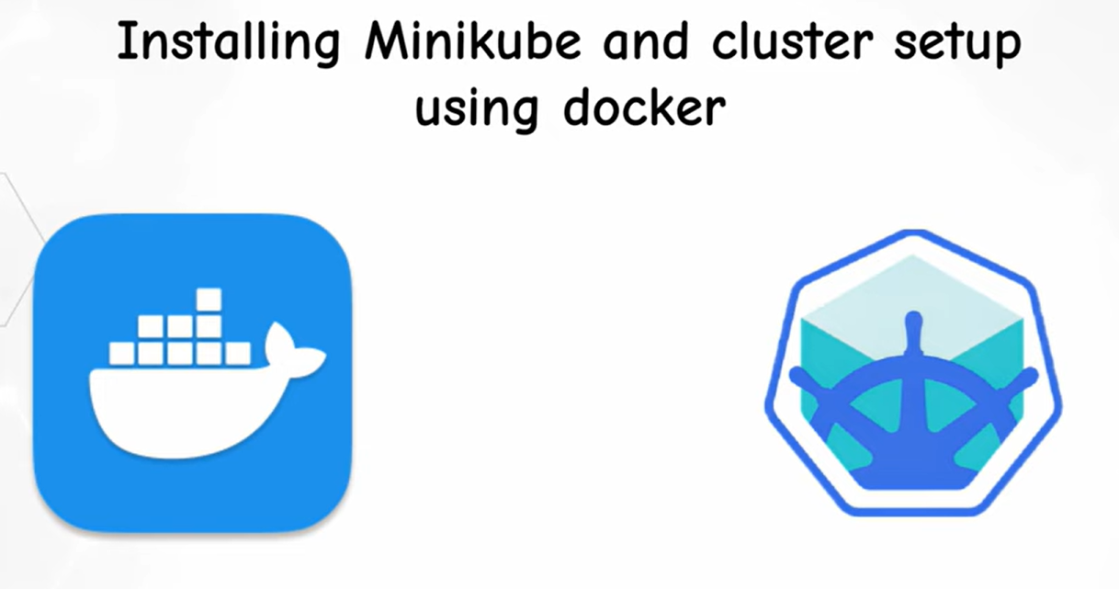

Download Docker desktop and complete setup

Download minikube for windows

minikube start

---start the cluster

Kubectl get pods

Kubectl get nodes

Kubectl get pods -A

Kubectl describe node minikube

Desire state 3----actual state – 1 ----3-1=2

ReplicaSet

----It is nothing if any of the pod got crashed it will create new pod that is what we are saying self healing

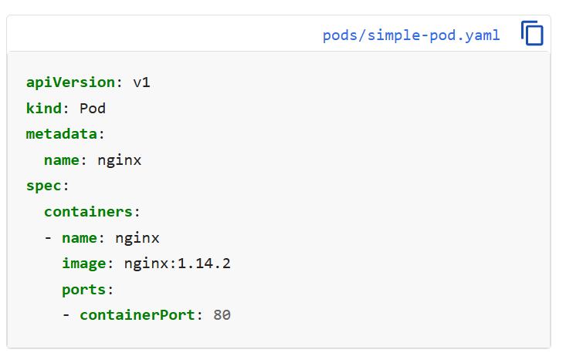

kubectl apply -f <https://k8s.io/examples/pods/simple-pod.yaml>

kubectl get pods

kubectl delete pod [podname]

pod creating files ---pod manifest

Replica creating files ---Replica Manifest